# BESANT TECHNOLOGIES

Python – Control Structures ASSIGNMENT

**Name** : THUYAMANIKUMARAKRISHNA B

**Batch** : 416

**Department** : ECE

**Year** : 2025

**Questions**

# Assignment :[control structures]

1. print numbers from 10-30 using "for" loop
2. print numbers from 0,2,4,6,8,10 using "for" loop
3. print series 50,45,40,35,30,25,20,15,10,5,0 using "for" loop
4. print first 5 natural even numbers and their squares using "for" loop
5. print table using "for" loop and accept table number from user
6. print sum of first 5 odd natural numbers using "for" loop
7. print factorial of a number using "for" loop
8. WAP for below mentioned conditions using logical operator? marks = 90 -> "excellent"

marks = 80 -> "good" marks = 65 -> "better" marks = below 35 -> "fail"

1. WAP to find greatest number among three numbers using nested if?
2. WAP to find smallest number among three numbers using logical operator?

## Answers

* 1. print numbers from 10-30 using "for" loop

## Code:

for i in range(10,31): print(i,end=" ")

## Output:

* 1. print numbers from 0,2,4,6,8,10 using "for" loop

## Code:

for i in range(0,11,2): print(i,end=" ")

## output:

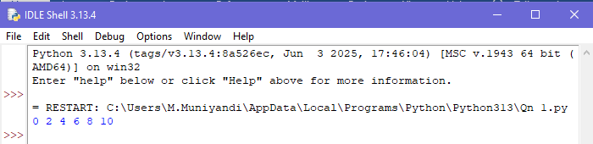

* 1. print series 50,45,40,35,30,25,20,15,10,5,0 using "for" loop

## Code:

for i in range(50,-1,-5):

print(i,end=" ")

## Output:

* 1. print first 5 natural even numbers and their squares using "for" loop

## Code:

for i in range(2,11,2): print(i,i**2)

## Output:

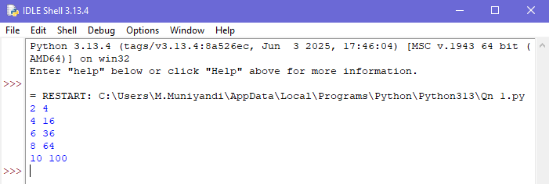

* 1. print table using "for" loop and accept table number from user

## Code:

x=int(input())

for i in range(1,11): print(i,"*",x,"=",i*x)

## Output:

* 1. print sum of first 5 odd natural numbers using "for" loop

## Code:

sum=0

for i in range(1,10): if(i%2!=0):

print(i,end=" ") sum+=i

print(",",sum,end=" ")

## Output:

* 1. print factorial of a number using "for" loop

## Code:

x=int(input()) fact=1

for i in range(1,x+1): fact=fact*i

print(fact,end=””)

## Output:

* 1. WAP for below mentioned conditions using logical operator? marks = 90 -> "excellent"

marks = 80 -> "good" marks = 65 -> "better" marks = below 35 -> "fail"?

## Code:

x=int(input()) if(x>=90):

print("excellent") elif(x>=80):

print("good") elif(x>=65 or x>=35):

print("berrer") else:

print("fail")

## Output:

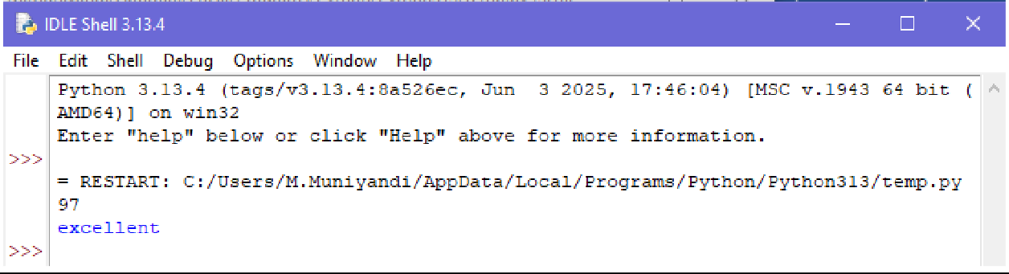

* 1. WAP to find greatest number among three numbers using nested if?

## Code:

num1=int(input()) num2=int(input()) num3=int(input()) if(num1>num2):

if(num1>num3): print("number 1 is big")

else:

print("number 3 is big")

else:

if(num2>num3): print("number 2 is big")

else:

print("number 3 is big")

## Output:

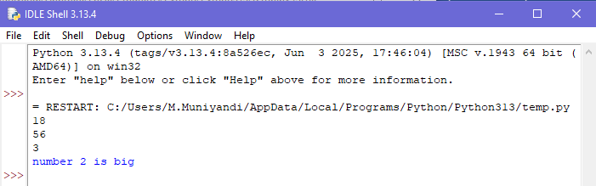

* 1. WAP to find smallest number among three numbers using logical operator?

## Code:

x=int(input()) y=int(input()) z=int(input())

if (x<y and x<z):

print("x is smaller number") elif (y<x and y<z):

print("y is smaller number") else:

print("z is smaller number")

**Output:**

